**ACA #4**

Social Network Analysis

Karl(Yiren) Shen

Basic Information

First of all, I don’t use social media very often. The only social media I have is WeChat which doesn’t support or have an API to help get my personal network. In this case, for this assignment, I searched online for available datasets and decide to use the dataset Heidler_relationship.gml which contains the relation network of a German boys' class in 1880. In terms of analysis tool for this assignment, I decided to use Gephi, it can utilize many kinds of visualization and explore all kinds of graphs, especially social networks.

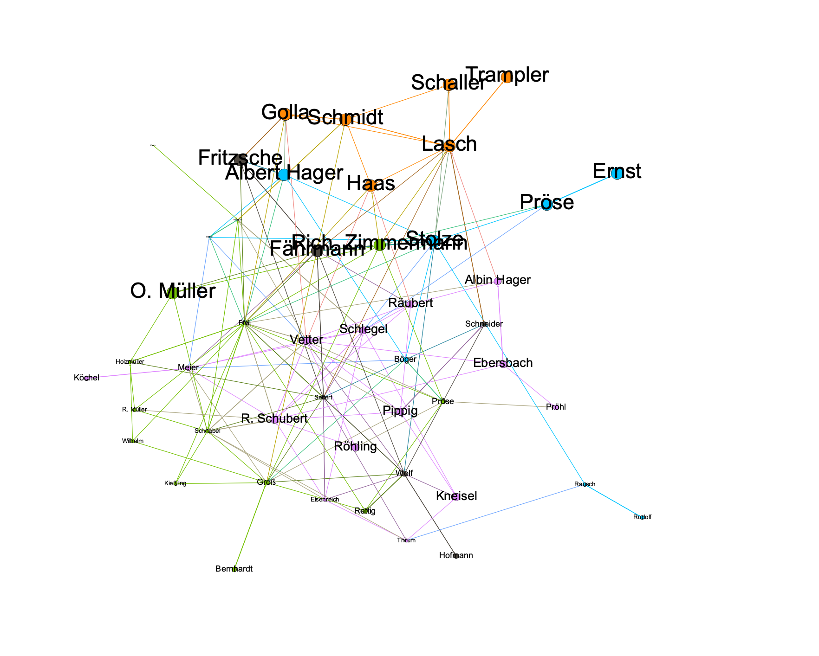

Figure 1. Overview of the Network

There is a total of 53 nodes and 179 edges (vertices). Nodes are the entities of the dataset, which in my case are the students in Heilder’s class. Edges are the lines that connect between the nodes of the network. In this case, the density of this network is 0.065. The diameter I calculated is 8 from the Gephi analysis.

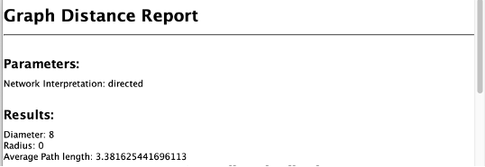

Figure 2. Diameter

Vertices

The average degree of this network is 3.38

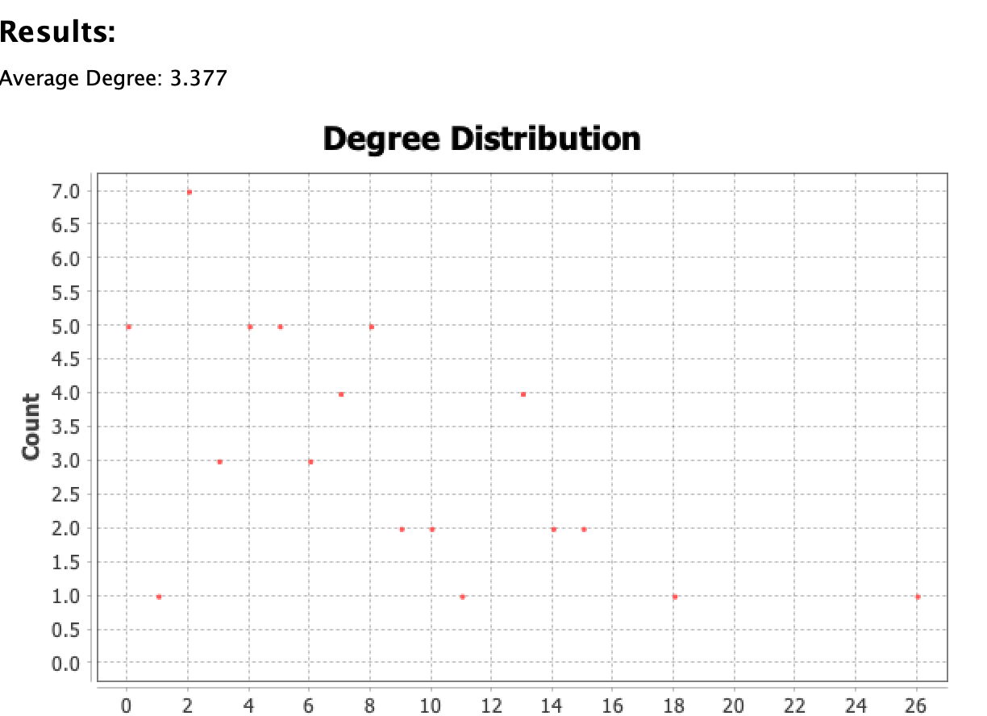

Figure 3. Average Degree

We have discussed the betweenness centrality and closeness centrality. Betweenness centrality is to detect the amount of influence a node has over the flow of a network. It will suggest the nodes that serve as a bridge from one part of a graph to another. Closeness centrality, on the other hand, it is to detect the nodes that are able to spread information efficiently through a network. The closeness centrality of a node measures its average farness (inverse distance) to all other nodes. In order to further compare these two centralities, I introduce a question: who is the most influential student in this class. In terms of betweenness centrality, Fahrmann is the most influential student in class, but Seifert is the most influential student in terms of closeness centrality.



Figure 4. Betweenness Centrality



Figure 5. Closeness Centrality

Then I run the Modularity analysis, which suggests the number of communities is 10.

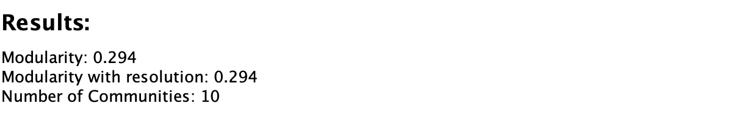

Figure 6. Modularity

Then I further look into the communities, I find that the first four communities contain 90% of the students, and there are several students who are sadly alone in their communities.

In conclusion, this network is a very typical relationship map of a school class for me. There are several popular students who seem to connect with every other student. And there are smaller social groups that students seem to more connect within their groups and they are students are kind of loners that don’t get involved in any groups. I can see from this assignment that Social Network Analysis is a very powerful technique that can help to better understand how individuals are connected. Moreover, it is helpful for stakeholders to get to know the network and make critical decisions like how to improve communication, team cohesion and etc.